**MATHEMATICS METHODS**

**MAWA Semester 1 (Unit 3) Examination 2020**

**Calculator-free**

# Marking Key

© MAWA, 2020

**Licence Agreement**

This examination is Copyright but may be freely used within the school that purchases this licence.

* The items that are contained in this examination are to be used solely in the school for which they are purchased.
* They are not to be shared in any manner with a school which has not purchased their own licence.
* The items and the solutions/marking keys are to be kept confidentially and not copied or made available to anyone who is not a teacher at the school. Teachers may give feedback to students in the form of showing them how the work is marked but students are not to retain a copy of the paper or marking guide until the agreed release date stipulated in the purchasing agreement/licence.

The release date for this exam and marking scheme is

* **June 12th the end of week 7 of term 2, 2020**

**Section One: Calculator-free (50 Marks)**

**Question 1(a) (2 marks)**

|  |  |
| --- | --- |
| Solution | |
|  | |
| Mathematical behaviours | Mark |
| * applies chain rule * obtains correct result | 1  1 |

**Question 1(b) (2 marks)**

|  |  |
| --- | --- |
| Solution | |
|  | |
| Mathematical behaviours | Marks |
| * differentiates cos term correctly * applies product rule and states result | 1  1 |

**Question 1(c) (3 marks)**

|  |  |
| --- | --- |
| Solution | |
|  | |
| Mathematical behaviours | Marks |
| * differentiates correctly * substitutes and simplifies to (*) * evaluates correctly, stating Pythagorean identity | 1  1  1 |

**Question 2(a) (2 marks)**

|  |  |
| --- | --- |
| Solution | |
|  | |
| Mathematical behaviours | Marks |
| * equates function to 0 and obtains * states | 1  1 |

**Question 2(b) (4 marks)**

|  |  |
| --- | --- |
| Solution | |
|  | |
| Mathematical behaviours | Marks |
| * differentiates, equates to 0 and solves * obtains correct $y$ values of the stationary points * uses second derivative test (or sign test) to determine nature of stationary   points   * locates point of inflection | 1  1  1  1 |

**Question 2(c) (1 mark)**

|  |  |
| --- | --- |
| Solution | |
|  | |
| Mathematical behaviours | Marks |
| * determines and concludes maximum | 1 |

|  |  |
| --- | --- |
| Solution | |
|  | |
| Mathematical behaviours | Marks |
| * plots zeros at 0 and such that * plots stationary points and point of inflection accurately * obtains correct shape for the graph, scale and end points | 1  1  1 |

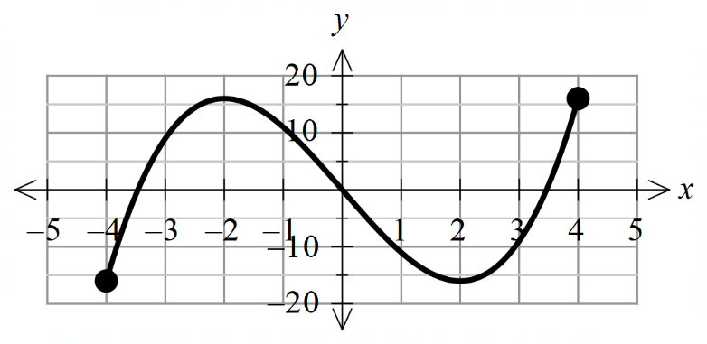**Question 2(d) (3 marks)**

**Question 3(a) (1 mark)**

|  |  |
| --- | --- |
| Solution | |
| , | |
| Mathematical behaviours | Mark |
| * states correct answer | 1 |

**Question 3(b) (4 marks)**

|  |  |
| --- | --- |
| Solution | |
|  | |
| Mathematical behaviours | Marks |
| * states the change as * anti-differentiates correctly * substitutes correct limits of integration * determines correct answer | 1  1  1  1 |

**Question 4(a) (2 marks)**

|  |  |
| --- | --- |
| Solution | |
|  | |
| Mathematical behaviours | Marks |
| * states the sum of probabilities is 1 * deduces *k* value | 1  1 |

**Question 4(b) (2 marks)**

|  |  |
| --- | --- |
| Solution | |
|  | |
| Mathematical behaviours | Marks |
| * states an expression to calculate required probability * determines probability | 1  1 |

**Question 4(c) (2 marks)**

|  |  |
| --- | --- |
| Solution | |
|  | |
| Mathematical behaviours | Marks |
| * writes fraction with the correct denominator * obtains simplified result | 1  1 |

**Question 5(a) (4 marks)**

|  |  |
| --- | --- |
| Solution | |
| (i)    (ii) | |
| Mathematical behaviours | Marks |
| (i)   * states anti-derivative * evaluates result   (ii)   * rewrites fraction as sum of two functions * anit-differentiates including | 1  1  1  1 |

**Question 5(b) (3 marks)**

|  |  |
| --- | --- |
| Solution | |
| (i)    (ii) | |
| Mathematical behaviours | Marks |
| (i)   * applies linearity of integrals, swaps bounds of integration and determines the correct result   (ii)   * applies linearity of integrals correctly * integrates correctly and calculates the result | 1  1  1 |

**Question 5(c) (5 marks)**

|  |  |
| --- | --- |
| Solution | |
|  | |
| Mathematical behaviours | Marks |
| * applies the chain rule to the derivative * differentiates correctly * recognises application of the Fundamental Theorem * factors out and re-writes fraction involving in numerator and denominator as one fraction squared * multiplies both sides of expression by to obtain desired result | 1  1  1  1  1 |

**Question 6(a) (3 marks)**

|  |  |
| --- | --- |
| Solution | |
|  | |
| Mathematical behaviours | Marks |
| * applies quotient rule * differentiates both parts correctly and states the value of *c* and *d* * simplifies result and states value of *a* and *b* | 1  1  1 |

**Question 6(b) (2 marks)**

|  |  |
| --- | --- |
| Solution | |
| So the coordinates of B are | |
| Mathematical behaviours | Marks |
| * equates derivative to 0 and solves * states co-ordinates of B | 1  1 |

|  |  |
| --- | --- |
| Solution | |
| It is the area between the two curves from *x* = 0 to *x* = π. | |
| Mathematical behaviours | Marks |
| * states it is the area between the two given curves * states the area is from  to | 1  1 |

**Question 7(a) (2 marks)**

**Question 7(b) (3 marks)**

|  |  |
| --- | --- |
| Solution | |
|  | |
| Mathematical behaviours | Marks |
| * anti-differentiates  correctly * anti-differentiates correctly * includes constant of integration | 1  1  1 |